Lovely Oven Socials
Facebook: https://web.facebook.com/Lovelyovendanang
Zalo: 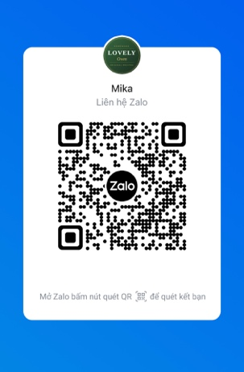
Whatsapp: +84 987390140

